
Sri Lanka Institute of Information Technology

Lab Submission
<Lab sheet No 6>

<IT24101931>
<Hettiarchchige G.D.P>

Probability and Statistics - IT2120
B.Sc. (Hons) in Information Technology
Lab Exercise 6
1.
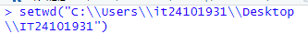

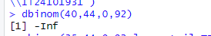

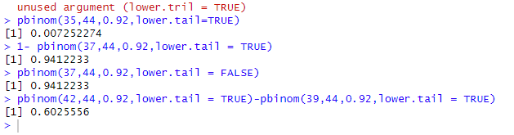
2.
- Number of babies born in a hospital on given day
- Poisson Distribution
Hera ,random variable X has poisson Distribution with lamda =5
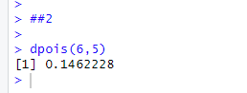

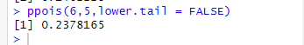

Exercise
1.
- binomial distribution
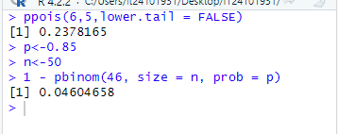

2.
- number of customer calls received in one hour
- Poisson Distribution
